**Assignment 1(Ex.No 9)**

1. This exercise involves the Auto data set studied in the lab. Make sure that the missing values have been removed from the data.
2. Which of the predictors are quantitative, and which are qualitative?

**Answer:**

**Qualitative: 'name', 'origin'**

**Quantitative: mpg, cylinders, displacement, horsepower, weight, acceleration, year**

1. What is the range of each quantitative predictor? You can answer this using the range() function.

**Answer:**

**mpg range: 9.0 - 46.6**

**cylinders range: 3 - 8**

**displacement range: 68.0 - 455.0**

**horsepower range: 46 - 230**

**weight range: 1613 - 5140**

**acceleration range: 8.0 - 24.8**

**year range: 70 - 82**

1. What is the mean and standard deviation of each quantitative predictor?

**Answer:**

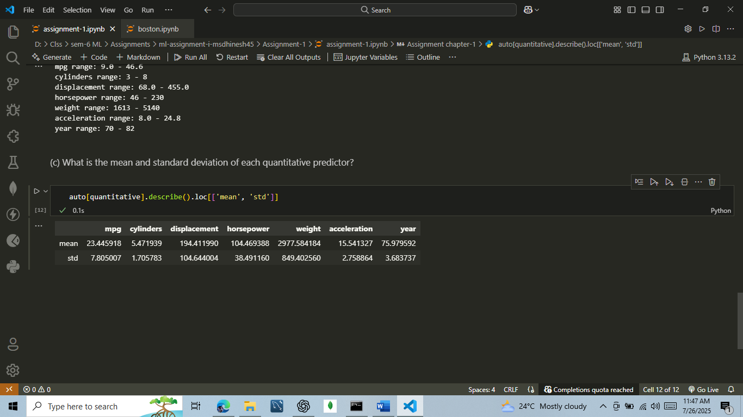

1. Now remove the 10th through 85th observations. What is the range, mean, and standard deviation of each predictor in the subset of the data that remains?

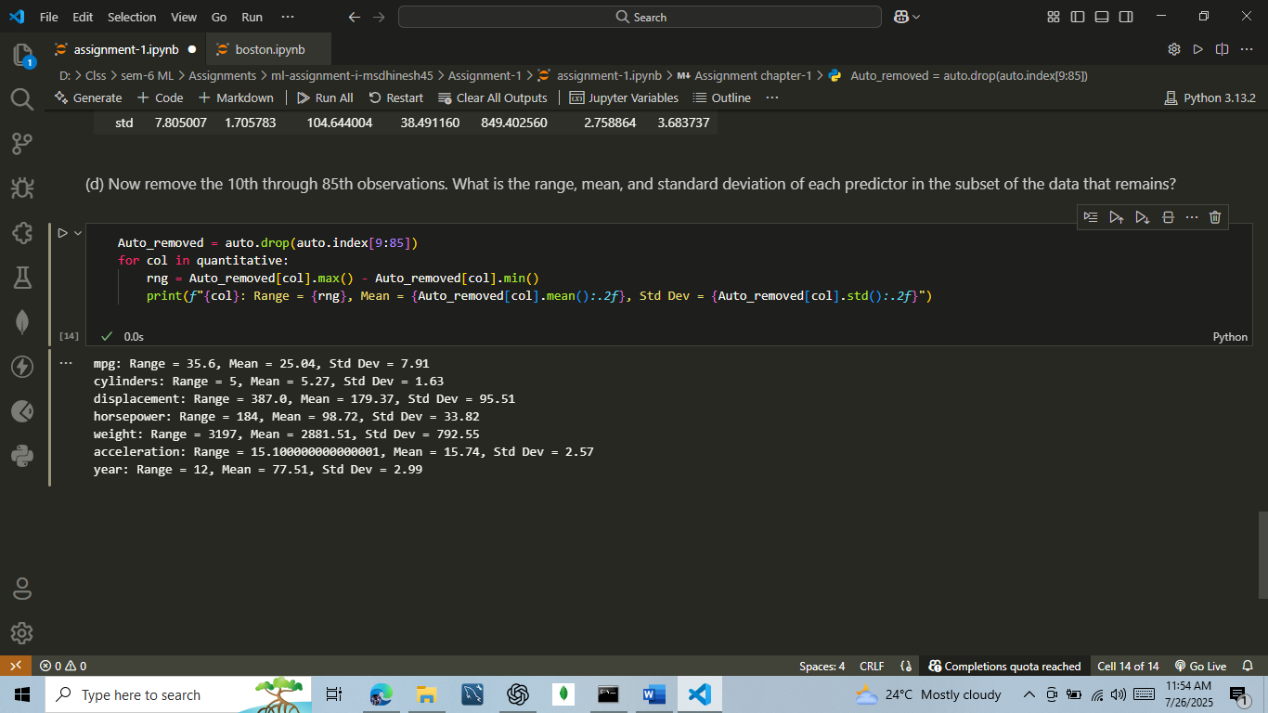

1. Using the full data set, investigate the predictors graphically, using scatterplots or other tools of your choice. Create some plots highlighting the relationships among the predictors. Comment on your findings.

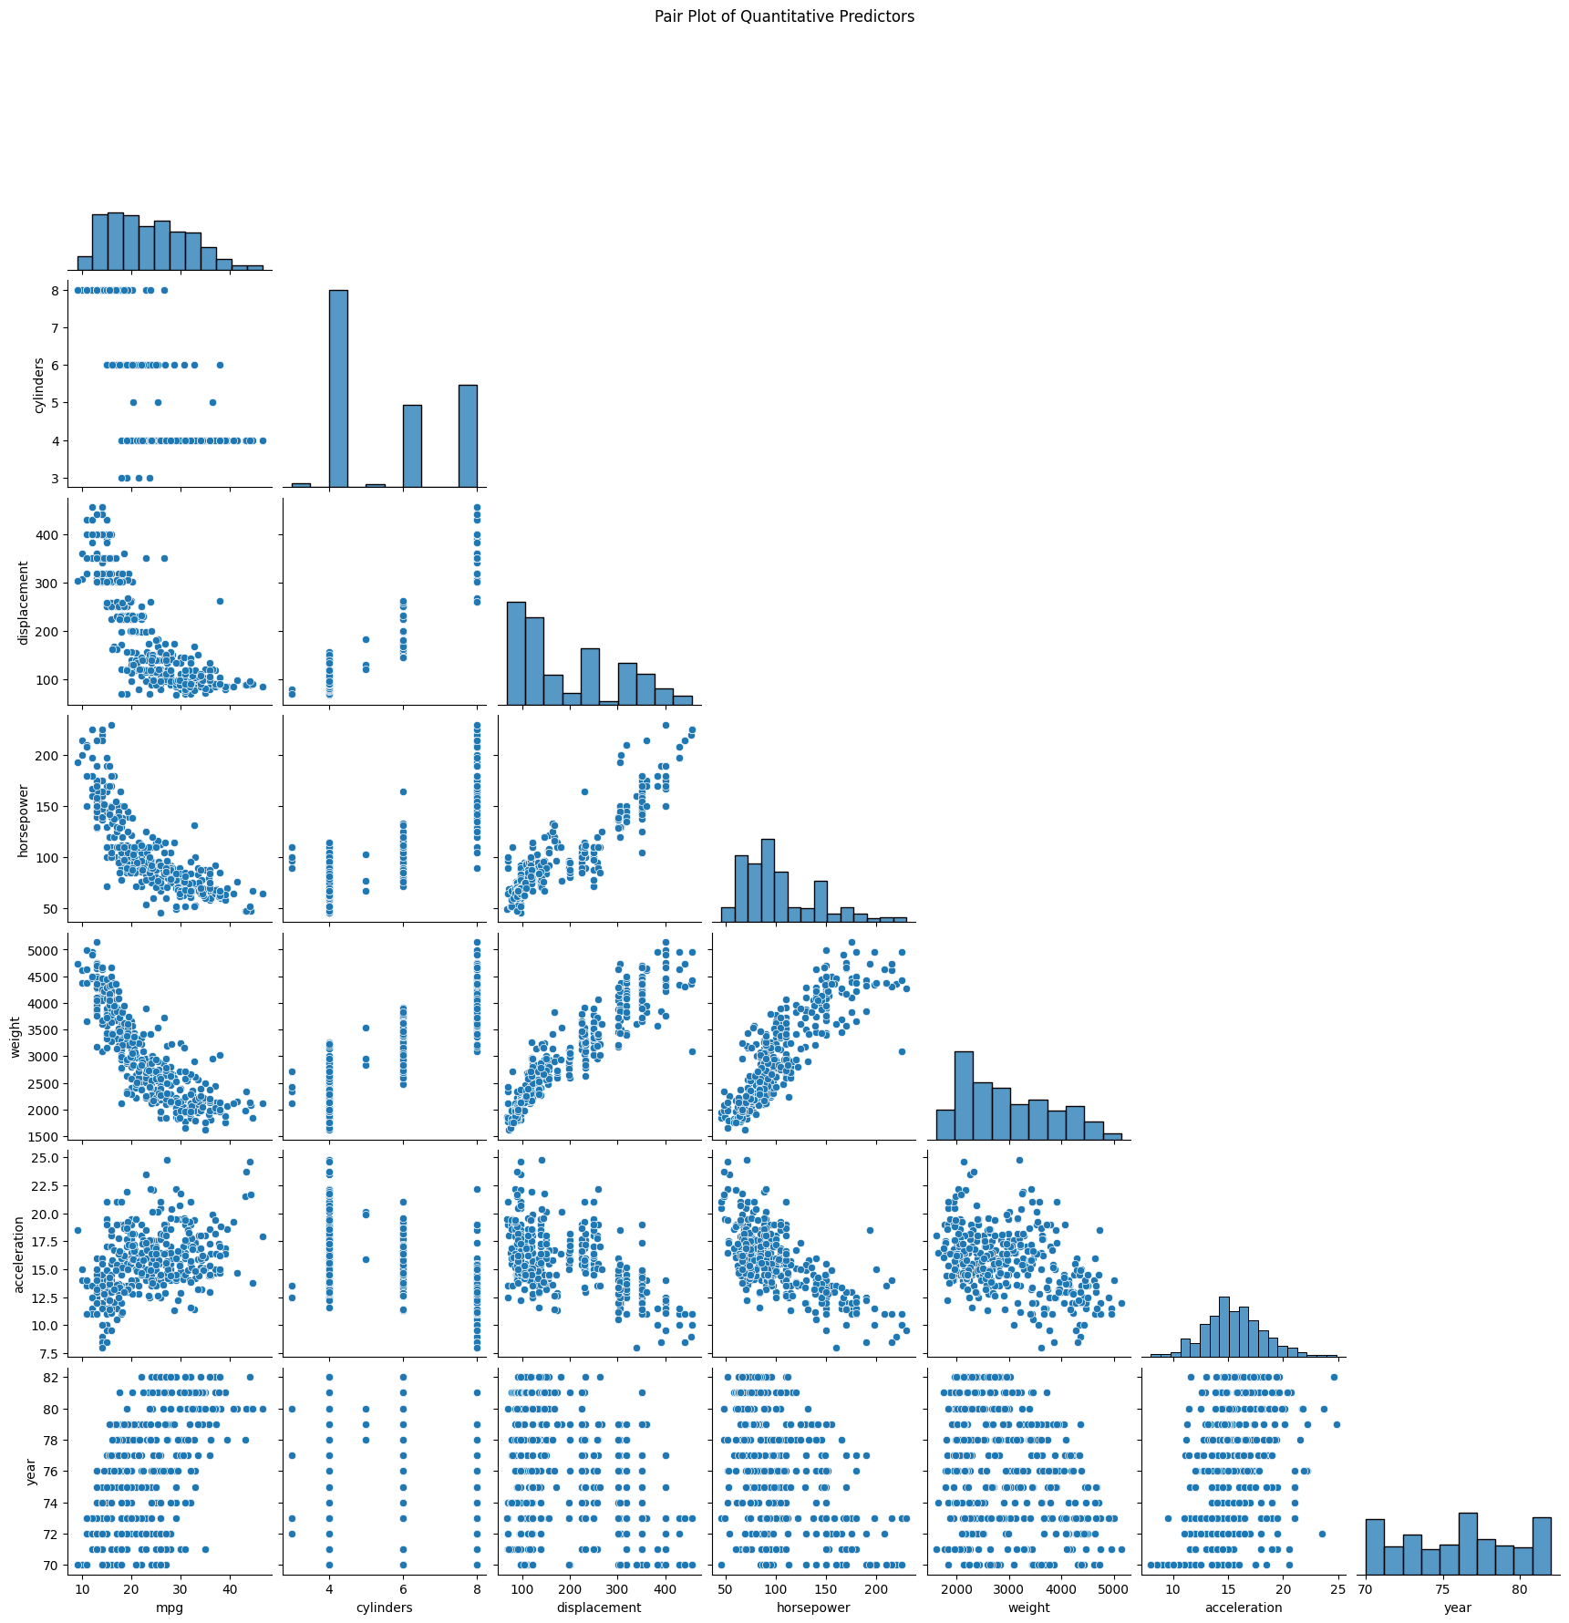

**Answer:**

**pair plot shows, Cars with bigger engines, more power, and heavier weight usually give lower mileage (mpg). Newer cars seem to give better mileage, maybe because of better technology. Acceleration doesn’t affect mileage much. Overall, engine size, power, and weight are linked and affect fuel efficiency.**

(f) Suppose that we wish to predict gas mileage (mpg) on the basis of the other variables. Do your plots suggest that any of the other variables might be useful in predicting mpg? Justify your answer

**Answer:**

**Yes, the plots suggest that some variables are useful in predicting mpg. We can see a strong negative relationship between mpg and variables like weight, horsepower, and displacement—as these values increase, mpg decreases. This means heavier or more powerful cars usually have lower fuel efficiency. Also, year shows a slight positive trend with mpg, so newer cars tend to be more fuel-efficient. These variables can help us predict mpg more accurately.**

**-- M.Dhinesh Kumar**

**-- II M.Sc CS**

**-- ML**